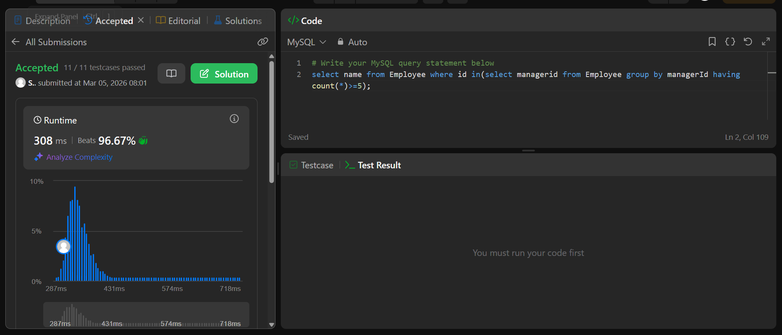

Querry- select name from Employee where id in(select managerid from Employee group by managerId having count(*)>=5);

